**Project Developed :**

Mustafa Bharmal : 92100133078

Yash Vara: 92100133056

Aryavardhan Sharma: 92100133081

**Project description:**

Our project aims to develop a comprehensive platform that connects clients (dealers) and a company, enabling clients to order products directly from the company and earn points in return. The platform will offer a wide range of gifts that can be redeemed using the earned points, including everyday items such as phones, headphones, speakers, makeup kits, and more.

The platform will have two distinct sides, an admin side, and a client side, each with its own set of functions. Admins will have the ability to create new gifts, confirm gifts redeemed by the user (dealer), add new clients and peers to the platform, and offer discounts on orders based on dates.

On the other hand, clients will be able to place orders, earn points, and redeem them for gifts from the gift section, which will resemble an e-commerce platform, complete with options like Cart, Place order, and many more. The platform will also feature a dashboard that displays important data such as points, sales of the month, and more.

To ensure a seamless user experience, the platform will provide multiple payment options before placing an order. Our project aims to provide a user-friendly and efficient platform that enhances the overall experience of both clients and admins.

**Er-Diagram:**

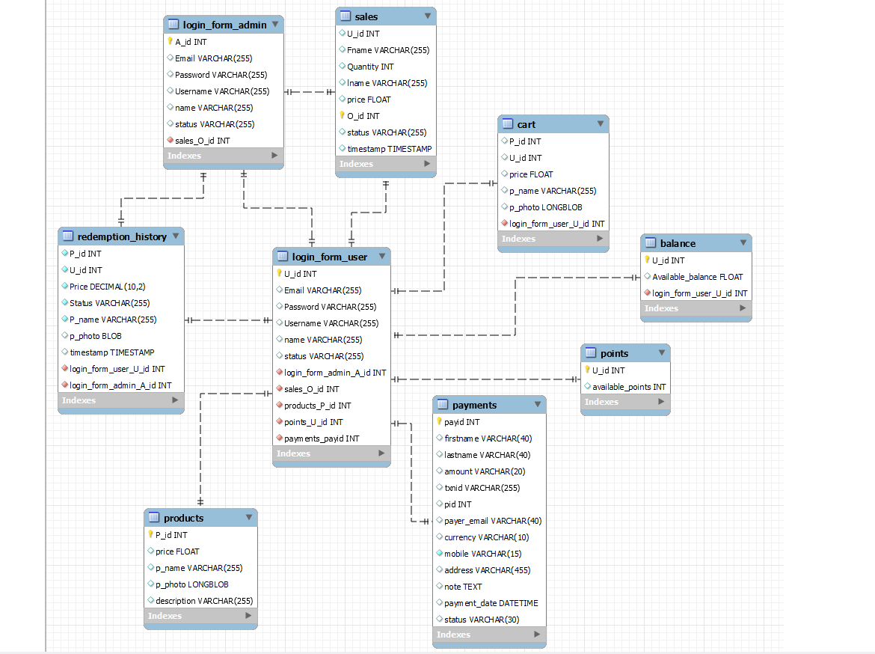

**Index page :**



**ADMIN SIDE :**

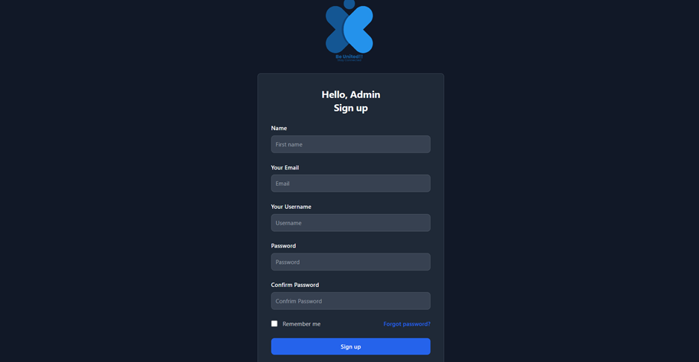

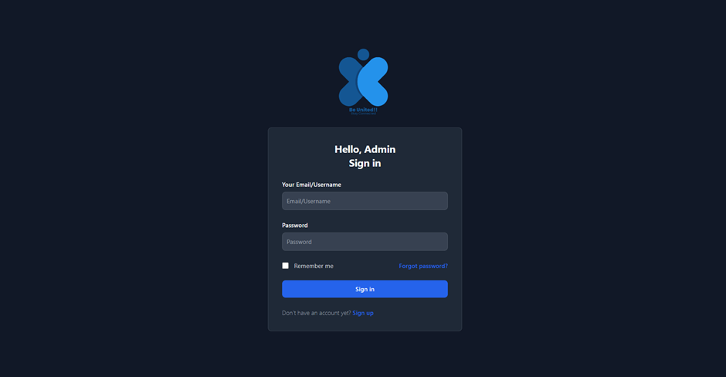

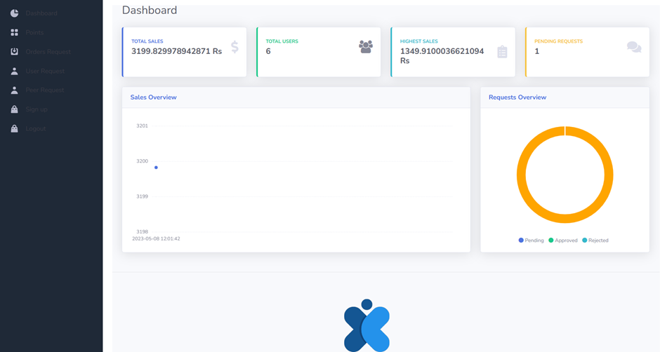

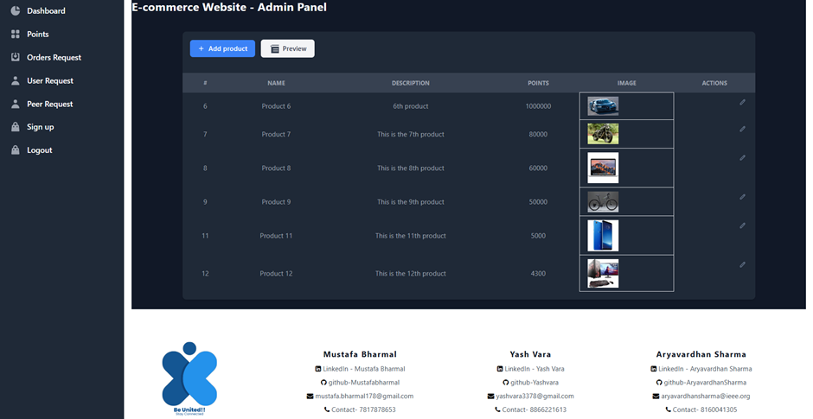

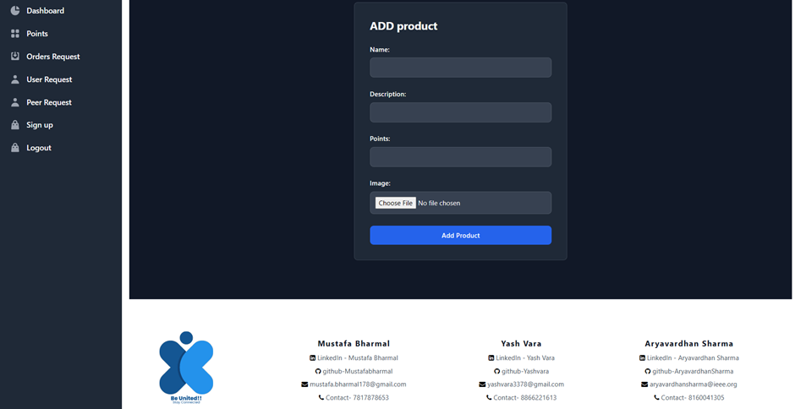

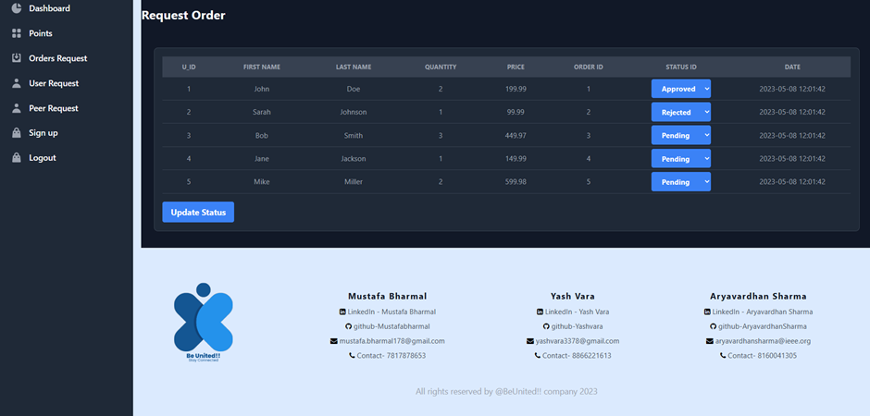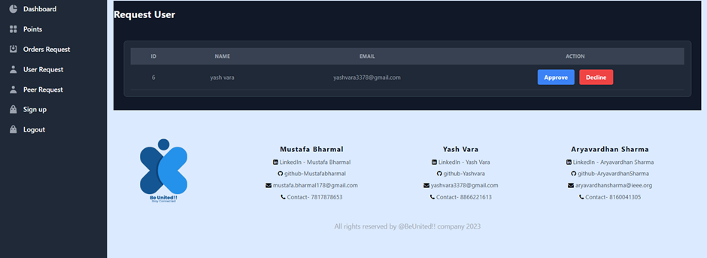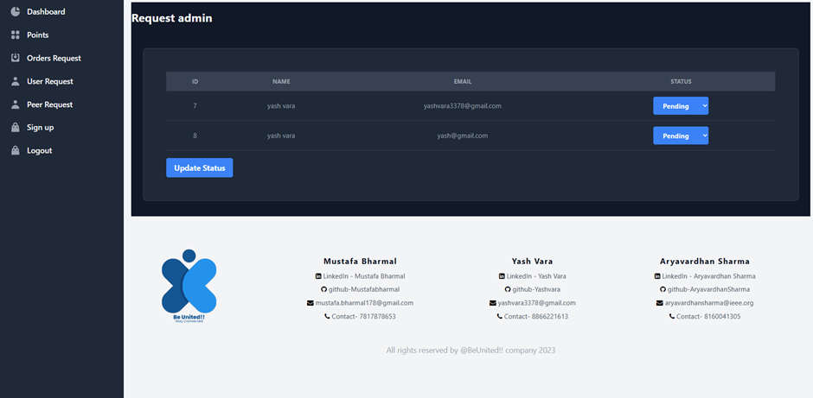

**CLIENT SIDE:**

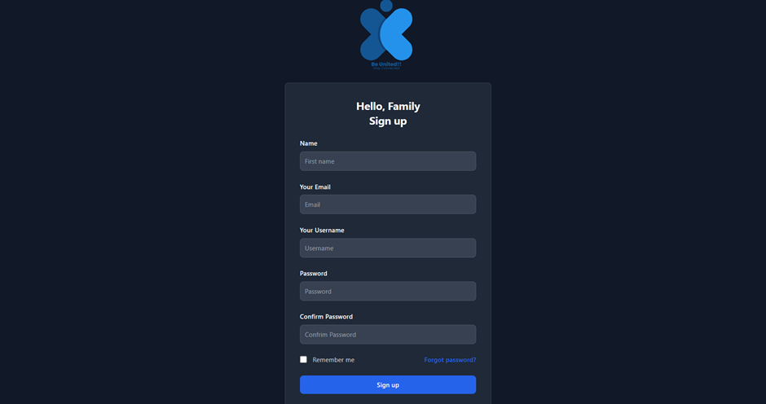

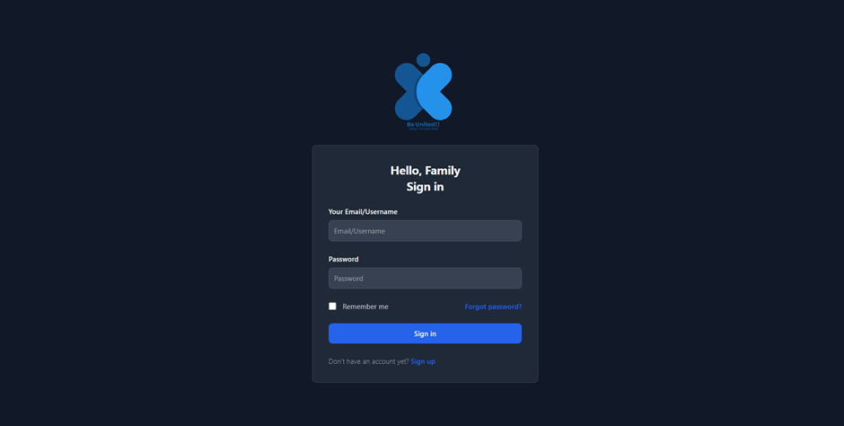

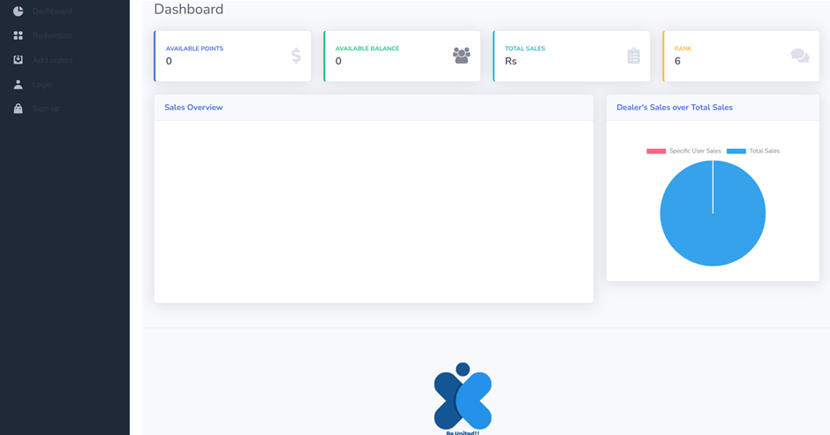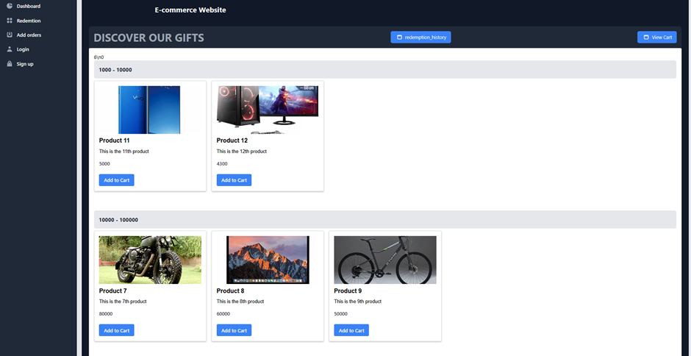

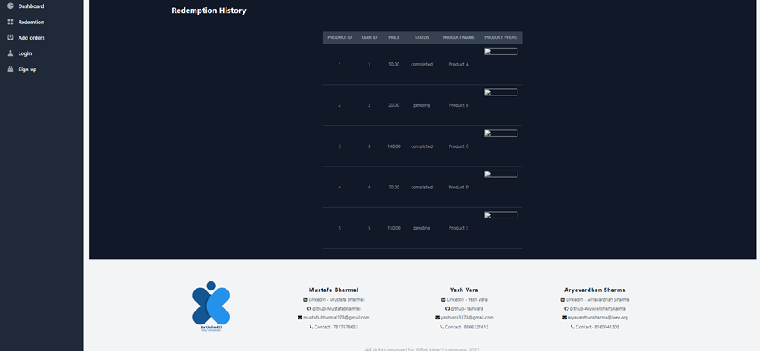

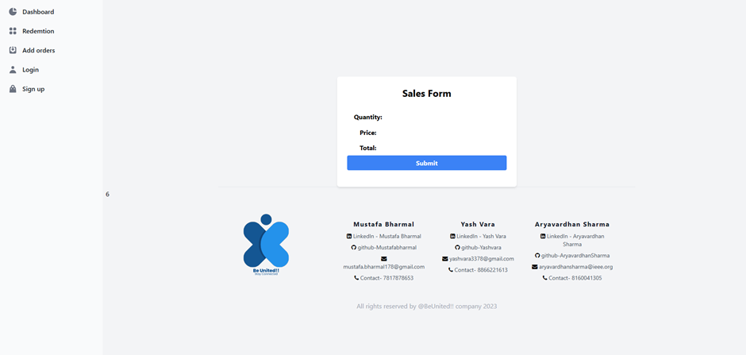

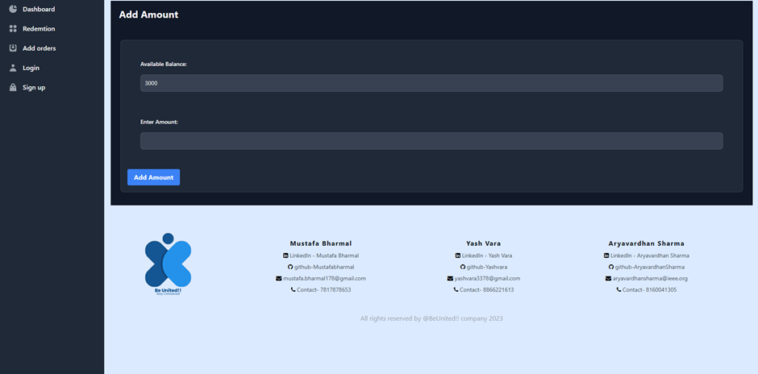

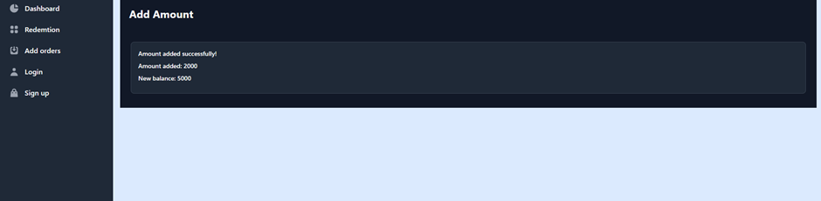

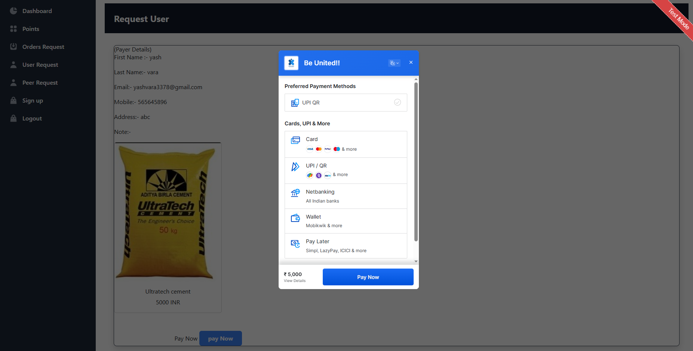

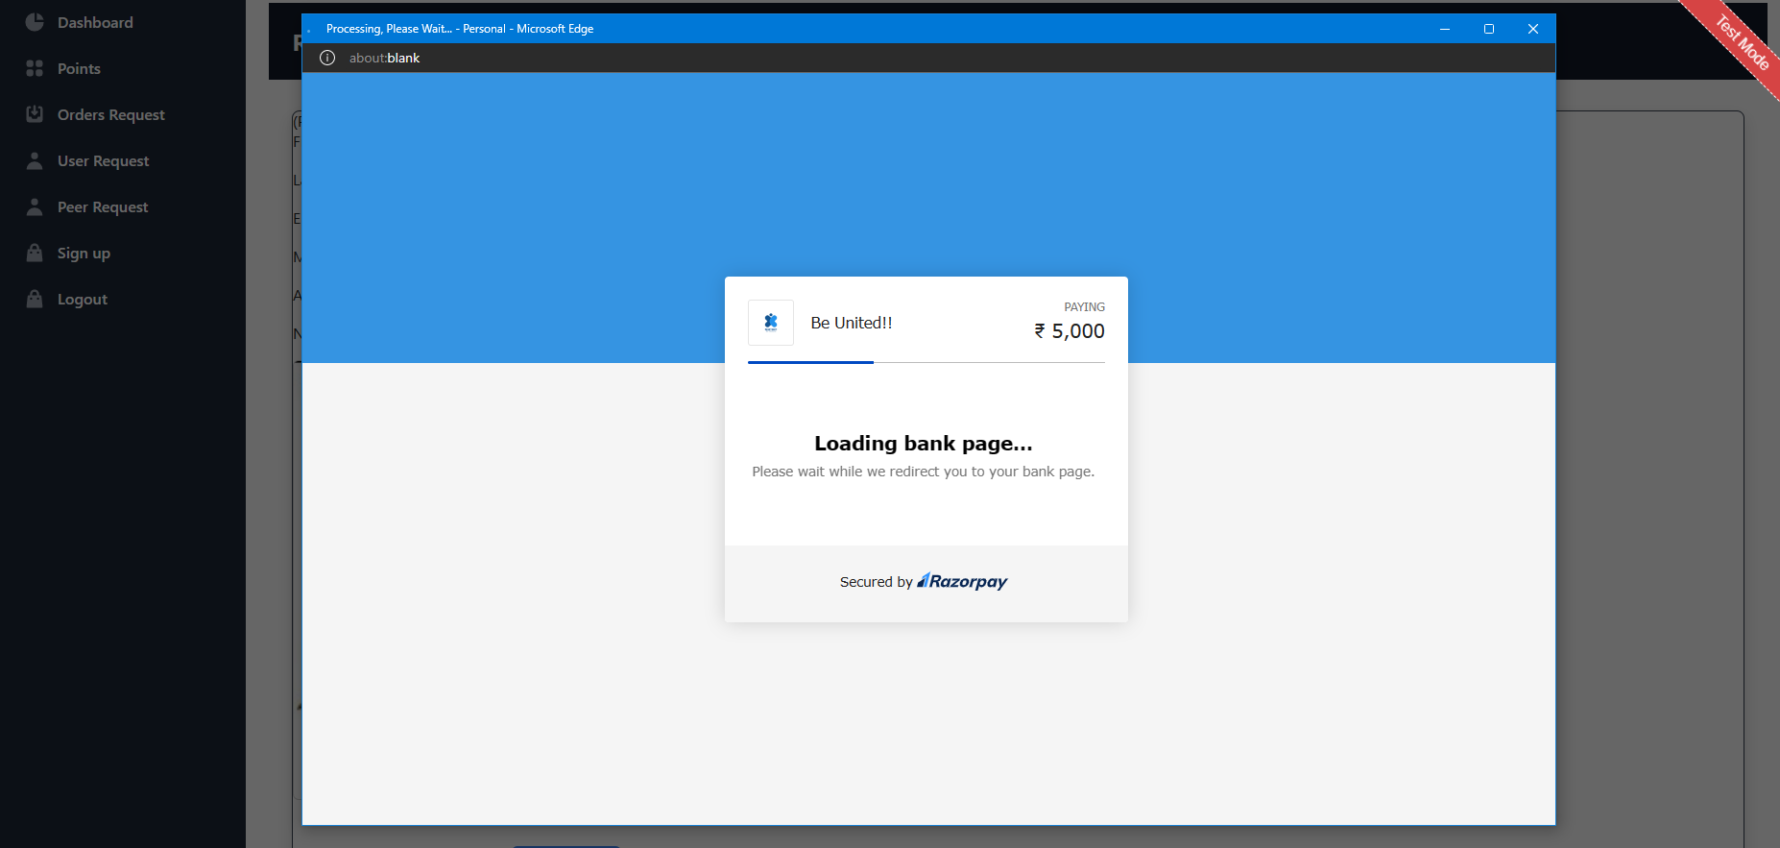

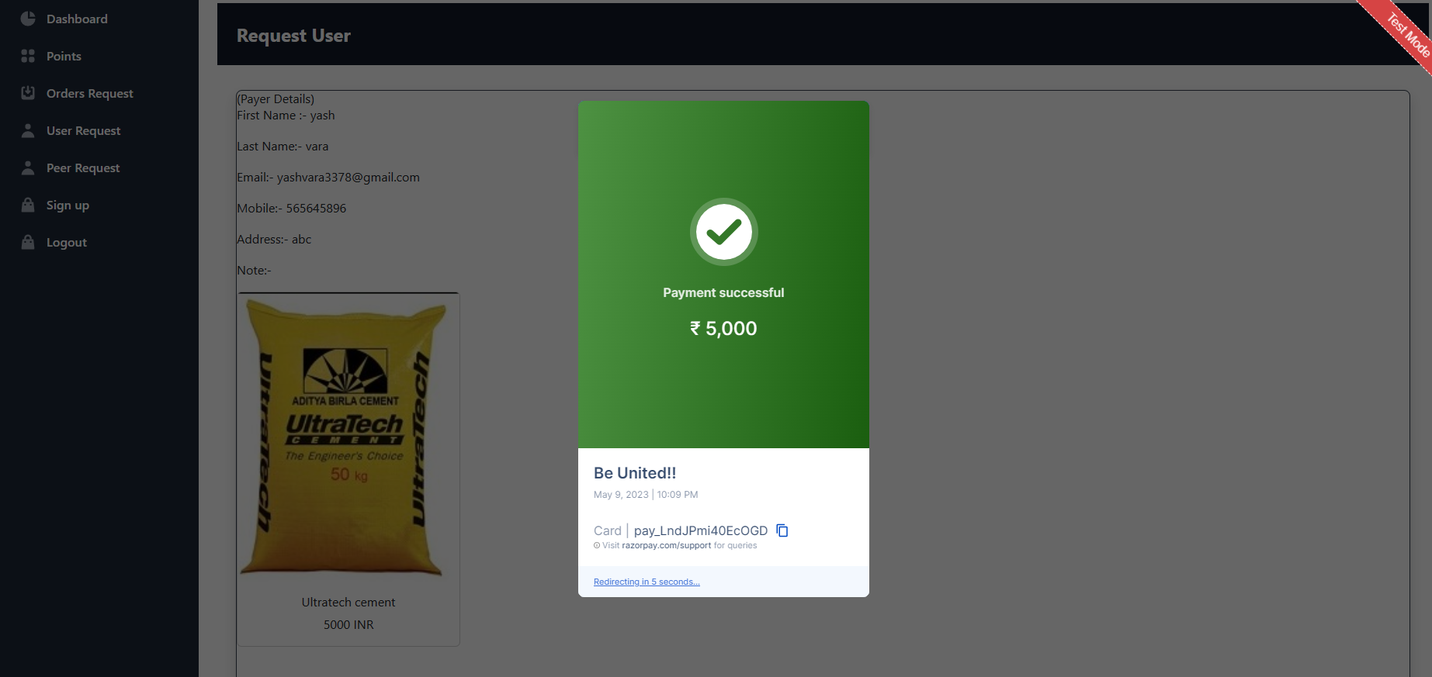

**SQL files :**

USE be_united;

CREATE TABLE Login_form_user (

U_id INT PRIMARY KEY auto_increment,

Email VARCHAR(255),

Password VARCHAR(255),

Username VARCHAR(255),

name varchar(255),

status varchar(255)

);

CREATE TABLE Login_form_admin (

A_id INT PRIMARY KEY auto_increment,

Email VARCHAR(255),

Password VARCHAR(255),

Username VARCHAR(255),

name varchar(255),

status varchar(255)

);

select * from Login_form_user;

CREATE TABLE Products (

P_id INT PRIMARY KEY auto_increment,

price FLOAT,

p_name VARCHAR(255),

p_photo LONGBLOB,

description VARCHAR(255)

);

CREATE TABLE Sales (

U_id INT,

Fname VARCHAR(255),

Quantity INT,

lname VARCHAR(255),

price FLOAT,

O_id INT PRIMARY KEY,

status VARCHAR(255),

timestamp TIMESTAMP

);

CREATE TABLE Cart (

P_id INT,

U_id INT,

price FLOAT,

p_name VARCHAR(255),

p_photo LONGBLOB

);

CREATE TABLE Points (

U_id INT ,

available_points INT

);

insert into Points(U_id,available_points) values(1,200);

CREATE TABLE Balance (

U_id INT,

Available_balance FLOAT

);

insert into Balance (U_id, Available_balance)

values ( 1, 3000.00),

(2, 5000.00);

insert into Balance (U_id, Available_balance)

values ( 6, 3000.00);

CREATE TABLE Redemption_history (

P_id INT,

U_id INT,

Price FLOAT,

Status VARCHAR(255),

P_name VARCHAR(255),

p_photo LONGBLOB,

timestamp TIMESTAMP

);